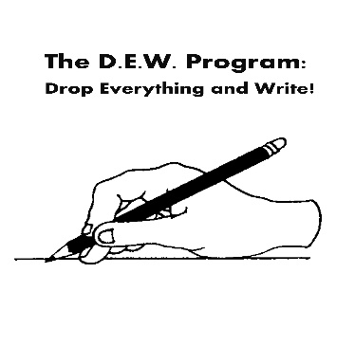

Upper Case Letters

Letters are grouped based on the starting stroke.

Tall line down:
F - Make a tall line down, jump up to the top line then make a sleeping line across the top lift pencil and a sleeping line across the middle
E – Make a tall line down, then a sleeping line across the bottom, jump up to the top line then make a sleeping line across the top, lift pencil and make a sleeping line across the middle
D – Make a tall line down, jump up to the top line and make a big belly down to the bottom line
P -Make a tall line down, jump up to the top line and make a half circle in front to the middle line
B – Make a tall line down, jump up to the top line make a half circle in front to the middle line then another half circle in front to the bottom line
R –Make a tall line down, jump up to the top line and make a half circle in front to the middle line, kiss the line then slide down to the bottom line
N – Start at the top line and make a tall line down, lift pencil, slide down to the bottom line then climb back up to the top line
M – Start at the top line and make a tall line down, lift pencil, slide down to the bottom line, slide back up to the top line then make a tall line down
H -Make a tall line down, lift pencil then make another tall line down, lift pencil then make a sleeping line across the middle line touching each tall line/connecting the tall lines
K -Make a tall line down, lift the pencil, start at the top line, slide in, kiss the line, then slide down to the bottom line
L -Make a tall line down then a sleeping line along the bottom line
U -Make a tall line down, dig a hole up to touch the top line
T -Make a tall line down, lift the pencil, start before the tall line down and make a sleeping line across at the top line
I – Make a tall line down, lift the pencil, start before the tall line down and make a sleeping line across at the top line and another sleeping line across at the bottom line
J – Make a tall line down and then a fish hook, lift the pencil start before the tall line down and make a sleeping line across at the top line
A-

C-Curve:
C -Make a big c-curve
G -Make a big c-curve, climb up to the middle line, make a sleeping line back towards the C-curve. Stop before the line touches the C-curve
O -Make a big c-curve, then close the circle
Q -Make a big c-curve, then close the circle, then lift the pencil then
S -Make a small c-curve that starts at the top line and ends at the middle line, then make a small backward c-curve

Sliding line:
V -Start at the top line and make a sliding line down to the bottom line then make a sliding line up to the top line
W -Start at the top line and make a sliding line down to the bottom line, make a sliding line up to the top line, make another sliding line down to the bottom line, make another sliding line up to the top line
X -Start at the top line and make a sliding line down to the bottom line, lift the pencil and start at the top line and make a backward sliding line that crosses the middle of the first line and ends on the bottom line
Y -Start at the top line and make a sliding line down to the middle line, lift pencil, start at the top line and make a backward sliding line that kisses the bottom of the first line then continues to the bottom line

Sleeping line:
Z -Make a sleeping line across the top line, make a backward sliding line to the bottom line then another sleeping line

